WELCOME TO

MY

FRONTEND DEVELOPMENT PROJECT

WORKED ON WEATHER APP

CREATED WEATHER APP BY USING HTML,CSS AND JAVA SCRIPT

TEAM ID:LTVIP2023TMIDO2468

TEAM SIZE:4

TEAM LEADER:GUGGILAPU PRASANTHI

TEAM MEMBER:KALAMATA SRUTHI

TEAM MEMBER:GANTA SIREESHA

TEAM MEMBER:GOUTHU NIRMALA

**CONTENTS**

1. INTRODUCTION
2. LITERATURE SURVEY
3. THEORITICAL ANALYSIS
4. RESULT
5. ADVANTAGES&DISADVANTAGES
6. APPLICATIONS
7. CONCLUSION
8. FUTURE SCOPE

rs. However, only a few of them have friendly user interface and human centered

interactions, which means that a lot of them might be difficult to be navigated even though

they provide enough functionalities. It is not convenient for new users. Therefore, we would

like to do improvements on weather mobile apps. It is basically for Apple smart phones and

tablets.

rs. However, only a few of them have friendly user interface and human centered

interactions, which means that a lot of them might be difficult to be navigated even though

they provide enough functionalities. It is not convenient for new users. Therefore, we would

like to do improvements on weather mobile apps. It is basically for Apple smart phones and

tablets.

Weather forecasting is the application of science and technology to predict the conditions of

the atmosphere for a given location and time. Weather forecasts are made by collecting

quantitative data about the current state of the atmosphere at a given place and using

meteorology to project how the atmosphere will change. The role of Technology has been

remarkable in the field of weather forecasting. Weather data is not only necessary for

researchers or scientists, ordinary people can be benefitted from it as well. People nowadays

are feeling the necessity of weather data as well. There are a variety of weather mobile apps in

Google Play and the App store. Those apps have great features and functionalities to satisfy

users. However, only a few of them have friendly user interface and human centered

interactions, which means that a lot of them might be difficult to be navigated even though

they provide enough functionalities. It is not convenient for new users. Therefore, we would

like to do improvements on weather mobile apps. It is basically for Apple smart phones and

table

Weather forecasting is the application of science and technology to predict the conditions of

the atmosphere for a given location and time. Weather forecasts are made by collecting

quantitative data about the current state of the atmosphere at a given place and using

meteorology to project how the atmosphere will change. The role of Technology has been

remarkable in the field of weather forecasting. Weather data is not only necessary for

researchers or scientists, ordinary people can be benefitted from it as well. People nowadays

are feeling the necessity of weather data as well. There are a variety of weather mobile apps in

Google Play and the App store. Those apps have great features and functionalities to satisfy

users. However, only a few of them have friendly user interface and human centered

interactions, which means that a lot of them might be difficult to be navigated even though

they provide enough functionalities. It is not convenient for new users. Therefore, we would

like to do improvements on weather mobile apps. It is basically for Apple smart phones and

table

Weather forecasting is the application of science and technology to predict the conditions of

the atmosphere for a given location and time. Weather forecasts are made by collecting

quantitative data about the current state of the atmosphere at a given place and using

meteorology to project how the atmosphere will change. The role of Technology has been

remarkable in the field of weather forecasting. Weather data is not only necessary for

researchers or scientists, ordinary people can be benefitted from it as well. People nowadays

are feeling the necessity of weather data as well. There are a variety of weather mobile apps in

Google Play and the App store. Those apps have great features and functionalities to satisfy

users. However, only a few of them have friendly user interface and human centered

interactions, which means that a lot of them might be difficult to be navigated even though

they provide enough functionalities. It is not convenient for new users. Therefore, we would

like to do improvements on weather mobile apps. It is basically for Apple smart phones and

table

Weather forecasting is the application of science and technology to predict the conditions of

the atmosphere for a given location and time. Weather forecasts are made by collecting

quantitative data about the current state of the atmosphere at a given place and using

meteorology to project how the atmosphere will change. The role of Technology has been

remarkable in the field of weather forecasting. Weather data is not only necessary for

researchers or scientists, ordinary people can be benefitted from it as well. People nowadays

are feeling the necessity of weather data as well. There are a variety of weather mobile apps in

Google Play and the App store. Those apps have great features and functionalities to satisfy

users. However, only a few of them have friendly user interface and human centered

interactions, which means that a lot of them might be difficult to be navigated even though

they provide enough functionalities. It is not convenient for new users. Therefore, we would

like to do improvements on weather mobile apps. It is basically for Apple smart phones and

table

Weather forecasting is the application of science and technology to predict the conditions of

the atmosphere for a given location and time. Weather forecasts are made by collecting

quantitative data about the current state of the atmosphere at a given place and using

meteorology to project how the atmosphere will change. The role of Technology has been

remarkable in the field of weather forecasting. Weather data is not only necessary for

researchers or scientists, ordinary people can be benefitted from it as well. People nowadays

are feeling the necessity of weather data as well. There are a variety of weather mobile apps in

Google Play and the App store. Those apps have great features and functionalities to satisfy

users. However, only a few of them have friendly user interface and human centered

interactions, which means that a lot of them might be difficult to be navigated even though

they provide enough functionalities. It is not convenient for new users. Therefore, we would

like to do improvements on weather mobile apps. It is basically for Apple smart phones and

table

Weather forecasting is the application of science and technology to predict the conditions of

the atmosphere for a given location and time. Weather forecasts are made by collecting

quantitative data about the current state of the atmosphere at a given place and using

meteorology to project how the atmosphere will change. The role of Technology has been

remarkable in the field of weather forecasting. Weather data is not only necessary for

researchers or scientists, ordinary people can be benefitted from it as well. People nowadays

are feeling the necessity of weather data as well. There are a variety of weather mobile apps in

Google Play and the App store. Those apps have great features and functionalities to satisfy

users. However, only a few of them have friendly user interface and human centered

interactions, which means that a lot of them might be difficult to be navigated even though

they provide enough functionalities. It is not convenient for new users. Therefore, we would

like to do improvements on weather mobile apps. It is basically for Apple smart phones and

table

Weather forecasting is the application of science and technology to predict the conditions of

the atmosphere for a given location and time. Weather forecasts are made by collecting

quantitative data about the current state of the atmosphere at a given place and using

meteorology to project how the atmosphere will change. The role of Technology has been

remarkable in the field of weather forecasting. Weather data is not only necessary for

researchers or scientists, ordinary people can be benefitted from it as well. People nowadays

are feeling the necessity of weather data as well. There are a variety of weather mobile apps in

Google Play and the App store. Those apps have great features and functionalities to satisfy

users. However, only a few of them have friendly user interface and human centered

interactions, which means that a lot of them might be difficult to be navigated even though

they provide enough functionalities. It is not convenient for new users. Therefore, we would

like to do improvements on weather mobile apps. It is basically for Apple smart phones and

table

Weather forecasting is the application of science and technology to predict the conditions of

the atmosphere for a given location and time. Weather forecasts are made by collecting

quantitative data about the current state of the atmosphere at a given place and using

meteorology to project how the atmosphere will change. The role of Technology has been

remarkable in the field of weather forecasting. Weather data is not only necessary for

researchers or scientists, ordinary people can be benefitted from it as well. People nowadays

are feeling the necessity of weather data as well. There are a variety of weather mobile apps in

Google Play and the App store. Those apps have great features and functionalities to satisfy

users. However, only a few of them have friendly user interface and human centered

interactions, which means that a lot of them might be difficult to be navigated even though

they provide enough functionalities. It is not convenient for new users. Therefore, we would

like to do improvements on weather mobile apps. It is basically for Apple smart phones and

table

Weather forecasting is the application of science and technology to predict the conditions of

the atmosphere for a given location and time. Weather forecasts are made by collecting

quantitative data about the current state of the atmosphere at a given place and using

meteorology to project how the atmosphere will change. The role of Technology has been

remarkable in the field of weather forecasting. Weather data is not only necessary for

researchers or scientists, ordinary people can be benefitted from it as well. People nowadays

are feeling the necessity of weather data as well. There are a variety of weather mobile apps in

Google Play and the App store. Those apps have great features and functionalities to satisfy

users. However, only a few of them have friendly user interface and human centered

interactions, which means that a lot of them might be difficult to be navigated even though

they provide enough functionalities. It is not convenient for new users. Therefore, we would

like to do improvements on weather mobile apps. It is basically for Apple smart phones and

table

Weather forecasting is the application of science and technology to predict the conditions of

the atmosphere for a given location and time. Weather forecasts are made by collecting

quantitative data about the current state of the atmosphere at a given place and using

meteorology to project how the atmosphere will change. The role of Technology has been

remarkable in the field of weather forecasting. Weather data is not only necessary for

researchers or scientists, ordinary people can be benefitted from it as well. People nowadays

are feeling the necessity of weather data as well. There are a variety of weather mobile apps in

Google Play and the App store. Those apps have great features and functionalities to satisfy

users. However, only a few of them have friendly user interface and human centered

interactions, which means that a lot of them might be difficult to be navigated even though

they provide enough functionalities. It is not convenient for new users. Therefore, we would

like to do improvements on weather mobile apps. It is basically for Apple smart phones and

table

Weather forecasting is the application of science and technology to predict the conditions of

the atmosphere for a given location and time. Weather forecasts are made by collecting

quantitative data about the current state of the atmosphere at a given place and using

meteorology to project how the atmosphere will change. The role of Technology has been

remarkable in the field of weather forecasting. Weather data is not only necessary for

researchers or scientists, ordinary people can be benefitted from it as well. People nowadays

are feeling the necessity of weather data as well. There are a variety of weather mobile apps in

Google Play and the App store. Those apps have great features and functionalities to satisfy

users. However, only a few of them have friendly user interface and human centered

interactions, which means that a lot of them might be difficult to be navigated even though

they provide enough functionalities. It is not convenient for new users. Therefore, we would

like to do improvements on weather mobile apps. It is basically for Apple smart phones and

table

Weather forecasting is the application of science and technology to predict the conditions of

the atmosphere for a given location and time. Weather forecasts are made by collecting

quantitative data about the current state of the atmosphere at a given place and using

meteorology to project how the atmosphere will change. The role of Technology has been

remarkable in the field of weather forecasting. Weather data is not only necessary for

researchers or scientists, ordinary people can be benefitted from it as well. People nowadays

are feeling the necessity of weather data as well. There are a variety of weather mobile apps in

Google Play and the App store. Those apps have great features and functionalities to satisfy

users. However, only a few of them have friendly user interface and human centered

interactions, which means that a lot of them might be difficult to be navigated even though

they provide enough functionalities. It is not convenient for new users. Therefore, we would

like to do improvements on weather mobile apps. It is basically for Apple smart phones and

table

Weather forecasting is the application of science and technology to predict the conditions of

the atmosphere for a given location and time. Weather forecasts are made by collecting

quantitative data about the current state of the atmosphere at a given place and using

meteorology to project how the atmosphere will change. The role of Technology has been

remarkable in the field of weather forecasting. Weather data is not only necessary for

researchers or scientists, ordinary people can be benefitted from it as well. People nowadays

are feeling the necessity of weather data as well. There are a variety of weather mobile apps in

Google Play and the App store. Those apps have great features and functionalities to satisfy

users. However, only a few of them have friendly user interface and human centered

interactions, which means that a lot of them might be difficult to be navigated even though

they provide enough functionalities. It is not convenient for new users. Therefore, we would

like to do improvements on weather mobile apps. It is basically for Apple smart phones and

table

Weather forecasting is the application of science and technology to predict the conditions of

the atmosphere for a given location and time. Weather forecasts are made by collecting

quantitative data about the current state of the atmosphere at a given place and using

meteorology to project how the atmosphere will change. The role of Technology has been

remarkable in the field of weather forecasting. Weather data is not only necessary for

researchers or scientists, ordinary people can be benefitted from it as well. People nowadays

are feeling the necessity of weather data as well. There are a variety of weather mobile apps in

Google Play and the App store. Those apps have great features and functionalities to satisfy

users. However, only a few of them have friendly user interface and human centered

interactions, which means that a lot of them might be difficult to be navigated even though

they provide enough functionalities. It is not convenient for new users. Therefore, we would

like to do improvements on weather mobile apps. It is basically for Apple smart phones and

tab

the atmosphere for a given location and time. Weather forecasts are made by collecting

quantitative data about the current state of the atmosphere at a given place and using

meteorology to project how the atmosphere will change. The role of Technology has been

remarkable in the field of weather forecasting. Weather data is not only necessary for

researchers or scientists, ordinary people can be benefitted from it as well. People nowadays

are feeling the necessity of weather data as well. There are a variety of weather mobile apps in

Google Play and the App store. Those apps have great features and functionalities to satisfy

users. However, only a few of them have friendly user interface and human centered

interactions, which means that a lot of them might be difficult to be navigated even though

they provide enough functionalities. It is not convenient for new users. Therefore, we would

like to do improvements on weather mobile apps. It is basically for Apple smart phones and

table

Weather forecasting is the application of science and technology to predict the conditions of

the atmosphere for a given location and time. Weather forecasts are made by collecting

quantitative data about the current state of the atmosphere at a given place and using

meteorology to project how the atmosphere will change. The role of Technology has been

remarkable in the field of weather forecasting. Weather data is not only necessary for

researchers or scientists, ordinary people can be benefitted from it as well. People nowadays

are feeling the necessity of weather data as well. There are a variety of weather mobile apps in

Google Play and the App store. Those apps have great features and functionalities to satisfy

users. However, only a few of them have friendly user interface and human centered

interactions, which means that a lot of them might be difficult to be navigated even though

they provide enough functionalities. It is not convenient for new users. Therefore, we would

like to do improvements on weather mobile apps. It is basically for Apple smart phones and

table

Weather forecasting is the application of science and technology to predict the conditions of

the atmosphere for a given location and time. Weather forecasts are made by collecting

quantitative data about the current state of the atmosphere at a given place and using

meteorology to project how the atmosphere will change. The role of Technology has been

remarkable in the field of weather forecasting. Weather data is not only necessary for

researchers or scientists, ordinary people can be benefitted from it as well. People nowadays

are feeling the necessity of weather data as well. There are a variety of weather mobile apps in

Google Play and the App store. Those apps have great features and functionalities to satisfy

users. However, only a few of them have friendly user interface and human centered

interactions, which means that a lot of them might be difficult to be navigated even though

they provide enough functionalities. It is not convenient for new users. Therefore, we would

like to do improvements on weather mobile apps. It is basically for Apple smart phones and

table

Weather forecasting is the application of science and technology to predict the conditions of

the atmosphere for a given location and time. Weather forecasts are made by collecting

quantitative data about the current state of the atmosphere at a given place and using

meteorology to project how the atmosphere will change. The role of Technology has been

remarkable in the field of weather forecasting. Weather data is not only necessary for

researchers or scientists, ordinary people can be benefitted from it as well. People nowadays

are feeling the necessity of weather data as well. There are a variety of weather mobile apps in

Google Play and the App store. Those apps have great features and functionalities to satisfy

users. However, only a few of them have friendly user interface and human centered

interactions, which means that a lot of them might be difficult to be navigated even though

they provide enough functionalities. It is not convenient for new users. Therefore, we would

like to do improvements on weather mobile apps. It is basically for Apple smart phones and

table

Weather forecasting is the application of science and technology to predict the conditions of

the atmosphere for a given location and time. Weather forecasts are made by collecting

quantitative data about the current state of the atmosphere at a given place and using

meteorology to project how the atmosphere will change. The role of Technology has been

remarkable in the field of weather forecasting. Weather data is not only necessary for

researchers or scientists, ordinary people can be benefitted from it as well. People nowadays

are feeling the necessity of weather data as well. There are a variety of weather mobile apps in

Google Play and the App store. Those apps have great features and functionalities to satisfy

users. However, only a few of them have friendly user interface and human centered

interactions, which means that a lot of them might be difficult to be navigated even though

they provide enough functionalities. It is not convenient for new users. Therefore, we would

like to do improvements on weather mobile apps. It is basically for Apple smart phones and

table

Weather forecasting is the application of science and technology to predict the conditions of

the atmosphere for a given location and time. Weather forecasts are made by collecting

quantitative data about the current state of the atmosphere at a given place and using

meteorology to project how the atmosphere will change. The role of Technology has been

remarkable in the field of weather forecasting. Weather data is not only necessary for

researchers or scientists, ordinary people can be benefitted from it as well. People nowadays

are feeling the necessity of weather data as well. There are a variety of weather mobile apps in

Google Play and the App store. Those apps have great features and functionalities to satisfy

users. However, only a few of them have friendly user interface and human centered

interactions, which means that a lot of them might be difficult to be navigated even though

they provide enough functionalities. It is not convenient for new users. Therefore, we would

like to do improvements on weather mobile apps. It is basically for Apple smart phones and

table

Weather forecasting is the application of science and technology to predict the conditions of

the atmosphere for a given location and time. Weather forecasts are made by collecting

quantitative data about the current state of the atmosphere at a given place and using

meteorology to project how the atmosphere will change. The role of Technology has been

remarkable in the field of weather forecasting. Weather data is not only necessary for

researchers or scientists, ordinary people can be benefitted from it as well. People nowadays

are feeling the necessity of weather data as well. There are a variety of weather mobile apps in

Google Play and the App store. Those apps have great features and functionalities to satisfy

users. However, only a few of them have friendly user interface and human centered

interactions, which means that a lot of them might be difficult to be navigated even though

they provide enough functionalities. It is not convenient for new users. Therefore, we would

like to do improvements on weather mobile apps. It is basically for Apple smart phones and

table

Weather forecasting is the application of science and technology to predict the conditions of

the atmosphere for a given location and time. Weather forecasts are made by collecting

quantitative data about the current state of the atmosphere at a given place and using

meteorology to project how the atmosphere will change. The role of Technology has been

remarkable in the field of weather forecasting. Weather data is not only necessary for

researchers or scientists, ordinary people can be benefitted from it as well. People nowadays

are feeling the necessity of weather data as well. There are a variety of weather mobile apps in

Google Play and the App store. Those apps have great features and functionalities to satisfy

users. However, only a few of them have friendly user interface and human centered

interactions, which means that a lot of them might be difficult to be navigated even though

they provide enough functionalities. It is not convenient for new users. Therefore, we would

like to do improvements on weather mobile apps. It is basically for Apple smart phones and

table

Weather forecasting is the application of science and technology to predict the conditions of

the atmosphere for a given location and time. Weather forecasts are made by collecting

quantitative data about the current state of the atmosphere at a given place and using

meteorology to project how the atmosphere will change. The role of Technology has been

remarkable in the field of weather forecasting. Weather data is not only necessary for

researchers or scientists, ordinary people can be benefitted from it as well. People nowadays

are feeling the necessity of weather data as well. There are a variety of weather mobile apps in

Google Play and the App store. Those apps have great features and functionalities to satisfy

users. However, only a few of them have friendly user interface and human centered

interactions, which means that a lot of them might be difficult to be navigated even though

they provide enough functionalities. It is not convenient for new users. Therefore, we would

like to do improvements on weather mobile apps. It is basically for Apple smart phones and

table

Weather forecasting is the application of science and technology to predict the conditions of

the atmosphere for a given location and time. Weather forecasts are made by collecting

quantitative data about the current state of the atmosphere at a given place and using

meteorology to project how the atmosphere will change. The role of Technology has been

remarkable in the field of weather forecasting. Weather data is not only necessary for

researchers or scientists, ordinary people can be benefitted from it as well. People nowadays

are feeling the necessity of weather data as well. There are a variety of weather mobile apps in

Google Play and the App store. Those apps have great features and functionalities to satisfy

users. However, only a few of them have friendly user interface and human centered

interactions, which means that a lot of them might be difficult to be navigated even though

they provide enough functionalities. It is not convenient for new users. Therefore, we would

like to do improvements on weather mobile apps. It is basically for Apple smart phones and

table

Weather forecasting is the application of science and technology to predict the conditions of

the atmosphere for a given location and time. Weather forecasts are made by collecting

quantitative data about the current state of the atmosphere at a given place and using

meteorology to project how the atmosphere will change. The role of Technology has been

remarkable in the field of weather forecasting. Weather data is not only necessary for

researchers or scientists, ordinary people can be benefitted from it as well. People nowadays

are feeling the necessity of weather data as well. There are a variety of weather mobile apps in

Google Play and the App store. Those apps have great features and functionalities to satisfy

users. However, only a few of them have friendly user interface and human centered

interactions, which means that a lot of them might be difficult to be navigated even though

they provide enough functionalities. It is not convenient for new users. Therefore, we would

like to do improvements on weather mobile apps. It is basically for Apple smart phones and

table

Weather forecasting is the application of science and technology to predict the conditions of

the atmosphere for a given location and time. Weather forecasts are made by collecting

quantitative data about the current state of the atmosphere at a given place and using

meteorology to project how the atmosphere will change. The role of Technology has been

remarkable in the field of weather forecasting. Weather data is not only necessary for

researchers or scientists, ordinary people can be benefitted from it as well. People nowadays

are feeling the necessity of weather data as well. There are a variety of weather mobile apps in

Google Play and the App store. Those apps have great features and functionalities to satisfy

users. However, only a few of them have friendly user interface and human centered

interactions, which means that a lot of them might be difficult to be navigated even though

they provide enough functionalities. It is not convenient for new users. Therefore, we would

like to do improvements on weather mobile apps. It is basically for Apple smart phones and

table

Weather forecasting is the application of science and technology to predict the conditions of

the atmosphere for a given location and time. Weather forecasts are made by collecting

quantitative data about the current state of the atmosphere at a given place and using

meteorology to project how the atmosphere will change. The role of Technology has been

remarkable in the field of weather forecasting. Weather data is not only necessary for

researchers or scientists, ordinary people can be benefitted from it as well. People nowadays

are feeling the necessity of weather data as well. There are a variety of weather mobile apps in

Google Play and the App store. Those apps have great features and functionalities to satisfy

users. However, only a few of them have friendly user interface and human centered

interactions, which means that a lot of them might be difficult to be navigated even though

they provide enough functionalities. It is not convenient for new users. Therefore, we would

like to do improvements on weather mobile apps. It is basically for Apple smart phones and

table

Weather forecasting is the application of science and technology to predict the conditions of

the atmosphere for a given location and time. Weather forecasts are made by collecting

quantitative data about the current state of the atmosphere at a given place and using

meteorology to project how the atmosphere will change. The role of Technology has been

remarkable in the field of weather forecasting. Weather data is not only necessary for

researchers or scientists, ordinary people can be benefitted from it as well. People nowadays

are feeling the necessity of weather data as well. There are a variety of weather mobile apps in

Google Play and the App store. Those apps have great features and functionalities to satisfy

users. However, only a few of them have friendly user interface and human centered

interactions, which means that a lot of them might be difficult to be navigated even though

they provide enough functionalities. It is not convenient for new users. Therefore, we would

like to do improvements on weather mobile apps. It is basically for Apple smart phones and

table

Weather forecasting is the application of science and technology to predict the conditions of

the atmosphere for a given location and time. Weather forecasts are made by collecting

quantitative data about the current state of the atmosphere at a given place and using

meteorology to project how the atmosphere will change. The role of Technology has been

remarkable in the field of weather forecasting. Weather data is not only necessary for

researchers or scientists, ordinary people can be benefitted from it as well. People nowadays

are feeling the necessity of weather data as well. There are a variety of weather mobile apps in

Google Play and the App store. Those apps have great features and functionalities to satisfy

users. However, only a few of them have friendly user interface and human centered

interactions, which means that a lot of them might be difficult to be navigated even though

they provide enough functionalities. It is not convenient for new users. Therefore, we would

like to do improvements on weather mobile apps. It is basically for Apple smart phones and

table

Weather forecasting is the application of science and technology to predict the conditions of

the atmosphere for a given location and time. Weather forecasts are made by collecting

quantitative data about the current state of the atmosphere at a given place and using

meteorology to project how the atmosphere will change. The role of Technology has been

remarkable in the field of weather forecasting. Weather data is not only necessary for

researchers or scientists, ordinary people can be benefitted from it as well. People nowadays

are feeling the necessity of weather data as well. There are a variety of weather mobile apps in

Google Play and the App store. Those apps have great features and functionalities to satisfy

users. However, only a few of them have friendly user interface and human centered

interactions, which means that a lot of them might be difficult to be navigated even though

they provide enough functionalities. It is not convenient for new users. Therefore, we would

like to do improvements on weather mobile apps. It is basically for Apple smart phones and

table

Weather forecasting is the application of science and technology to predict the conditions of

the atmosphere for a given location and time. Weather forecasts are made by collecting

quantitative data about the current state of the atmosphere at a given place and using

meteorology to project how the atmosphere will change. The role of Technology has been

remarkable in the field of weather forecasting. Weather data is not only necessary for

researchers or scientists, ordinary people can be benefitted from it as well. People nowadays

are feeling the necessity of weather data as well. There are a variety of weather mobile apps in

Google Play and the App store. Those apps have great features and functionalities to satisfy

users. However, only a few of them have friendly user interface and human centered

interactions, which means that a lot of them might be difficult to be navigated even though

they provide enough functionalities. It is not convenient for new users. Therefore, we would

like to do improvements on weather mobile apps. It is basically for Apple smart phones and

table

Weather forecasting is the application of science and technology to predict the conditions of

the atmosphere for a given location and time. Weather forecasts are made by collecting

quantitative data about the current state of the atmosphere at a given place and using

meteorology to project how the atmosphere will change. The role of Technology has been

remarkable in the field of weather forecasting. Weather data is not only necessary for

researchers or scientists, ordinary people can be benefitted from it as well. People nowadays

are feeling the necessity of weather data as well. There are a variety of weather mobile apps in

Google Play and the App store. Those apps have great features and functionalities to satisfy

users. However, only a few of them have friendly user interface and human centered

interactions, which means that a lot of them might be difficult to be navigated even though

they provide enough functionalities. It is not convenient for new users. Therefore, we would

like to do improvements on weather mobile apps. It is basically for Apple smart phones and

table

Weather forecasting is the application of science and technology to predict the conditions of

the atmosphere for a given location and time. Weather forecasts are made by collecting

quantitative data about the current state of the atmosphere at a given place and using

meteorology to project how the atmosphere will change. The role of Technology has been

remarkable in the field of weather forecasting. Weather data is not only necessary for

researchers or scientists, ordinary people can be benefitted from it as well. People nowadays

are feeling the necessity of weather data as well. There are a variety of weather mobile apps in

Google Play and the App store. Those apps have great features and functionalities to satisfy

users. However, only a few of them have friendly user interface and human centered

interactions, which means that a lot of them might be difficult to be navigated even though

they provide enough functionalities. It is not convenient for new users. Therefore, we would

like to do improvements on weather mobile apps. It is basically for Apple smart phones and

table

rs. However, only a few of them have friendly user interface and human centered

interactions, which means that a lot of them might be difficult to be navigated even though

they provide enough functionalities. It is not convenient for new users. Therefore, we would

like to do improvements on weather mobile apps. It is basically for Apple smart phones and

tablets.

rs. However, only a few of them have friendly user interface and human centered

interactions, which means that a lot of them might be difficult to be navigated even though

they provide enough functionalities. It is not convenient for new users. Therefore, we would

like to do improvements on weather mobile apps. It is basically for Apple smart phones and

tablets.

rs. However, only a few of them have friendly user interface and human centered

interactions, which means that a lot of them might be difficult to be navigated even though

they provide enough functionalities. It is not convenient for new users. Therefore, we would

like to do improvements on weather mobile apps. It is basically for Apple smart phones and

tablet

**INTRODUCTION**

Weather forecasting is the application of science and technology to predict the conditions of

the atmosphere for a given location and time. Weather forecasts are made by collecting

quantitative data about the current state of the atmosphere at a given place and using

meteorology to project how the atmosphere will change. The role of Technology has been

remarkable in the field of weather forecasting. Weather data is not only necessary for

researchers or scientists, ordinary people can be benefitted from it as well. People nowadays

are feeling the necessity of weather data as well. There are a variety of weather mobile apps in

Google Play and the App store. Those apps have great features and functionalities to satisfy

users. However, only a few of them have friendly user interface and human centered

interactions, which means that a lot of them might be difficult to be navigated even though

they provide enough functionalities. It is not convenient for new users. Therefore, we would

like to do improvements on weather mobile apps. It is basically for Apple smart phones and

tablets.

**OVERVIEW:**

8

1. INTRODUCTION

Weather forecasting is the application of science and technology to predict the conditions of

the atmosphere for a given location and time. Weather forecasts are made by collecting

quantitative data about the current state of the atmosphere at a given place and using

meteorology to project how the atmosphere will change. The role of Technology has been

remarkable in the field of weather forecasting. Weather data is not only necessary for

researchers or scientists, ordinary people can be benefitted from it as well. People nowadays

are feeling the necessity of weather data as well. There are a variety of weather mobile apps in

Google Play and the App store. Those apps have great features and functionalities to satisfy

users. However, only a few of them have friendly user interface and human centered

interactions, which means that a lot of them might be difficult to be navigated even though

they provide enough functionalities. It is not convenient for new users. Therefore, we would

like to do improvements on weather mobile apps. It is basically for Apple smart phones and

tablets.

1.1 OVERVIEW

The project, the “WEATHER FORCASTING APP” is a cutting edge and versatile Weather

application fundamentally designed to help people to travel long distances connect with their

near place ones in a very friendly, easy and hassle-free manner. This application is compatible

with all the Android versions. And with said that, anyone owing their own android phone, the

Weather Report application can create a huge difference in hooking them up with others

provided, they also have the same application loaded on their device or PC. It is very simple to

use and easy to install that can be downloaded directly. When it comes to the features, they all

are extremely engaging and they keep updating periodically back to back. The extent of fun in

using this Weather application is beyond comparison. This application is highly accommodative

for quick technological updates and integration. The application will have the features like

providing Forecast, Humidity, Pressure etc. It also provides Forecast Weather for 7 Days all

over

The project, the “WEATHER FORCASTING APP” is a cutting edge and versatile Weather

application fundamentally designed to help people to travel long distances connect with their

near place ones in a very friendly, easy and hassle-free manner. This application is compatible

with all the Android versions. And with said that, anyone owing their own android phone, the

Weather Report application can create a huge difference in hooking them up with others

provided, The application will have the features like

providing Forecast, Humidity, Pressure etc. It also provides Forecast Weather for 7 Days all

over the world.

**PURPOSE:**

n today’s busy routine life, the users of this Weather Report application will be just a click away

to access all the basic requirements in today’s day to day routine of the humans. The users will

have access to the latest Weather updates i.e. the burning Weather in all around the world.

Secondly, the users will have the access to the weather forecast before going out of their home

with the support of the GPS in their smart-phones. Compared to the other applications this

Weather Report application will prove to be an amazing user friendly application with lots of

more feature

In today’s busy routine life, the users of this Weather Report application will be just a click away to access all the basic requirements in today’s day to day routine of the humans. The users will have access to the latest Weather updates i.e. the burning Weather in all around the world.

Secondly, the users will have the access to the weather forecast before going out of their home with the support of the GPS in their smart-phones. Compared to the other applications this Weather Report application will prove to be an amazing user friendly application with lots of more features

To make a real time weather application that takes user’s exact location and provides

weather forecast for the day and upcoming days also. We also tried to design a simple

but visual UI that provides comprehensive data. Also, the application provides

suggestions to users based on weather conditions. And lastly, user can search and

access data for custom locations (string based).

**LITERATURE REVIEW**

**PROBLEM**:

9

1.2 PROJECT AIM

To make areal time weather application that takes user’s exact location and provides

weather forecast for the day and upcoming days also. We also tried to design a simple

but visual UI that provides comprehensive data. Also, the application provides

suggestions to users based on weather conditions. And lastly, user can search and

access data for custom locations (string based)

Weather apps are not all the same. There are tens of thousands of them, from the simply designed Apple Weather to the expensive, complex, data-rich Windy.App. But all of these forecasts are working off of similar data, which are pulled from places such as the National Oceanic and Atmospheric Administration (NOAA) and the European Centre for Medium-Range Weather Forecasts. Traditional meteorologists interpret these models based on their training as well as their gut instinct and past regional weather patterns, and different weather apps and services tend to use their own secret sauce of algorithms to divine their predictions.

It is the weather data source. All the app does is report what it downloads from whatever the weather source is, and the weather source gets it's information from weather stations around the world. And, while weather prediction is better than it was 100 years ago, it still isn't perfect. Well, their ability to predict the weather is limited by three factors: the amount of available data; the time available to analyze it; and. the complexity of weather events.

**SOLUTION:**

Weather has all the features you'd expect from one of the best weather apps, including a 10-day forecast, live radar maps, severe weather warnings and more. But it also really takes advantage of widgets so that key weather day can be visible on your phone's home screen, whether you're using Android or ios.

If the weather app is one of your most essential apps, then you can use alternative apps that would give you the same weather reports and scenarios in your locality. There are plenty of apps to use in place of the weather app on your iOS. Here are a few good apps to consider:

* CARROT Weather
* Dark Sky
* Hurricane by American Red Cross
* RadarScope
* The Weather Channel

**THEORITICAL ANALYSIS**

**BLOCK DIAGRAM:**

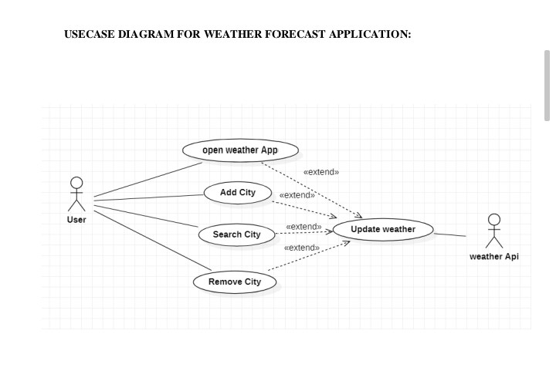 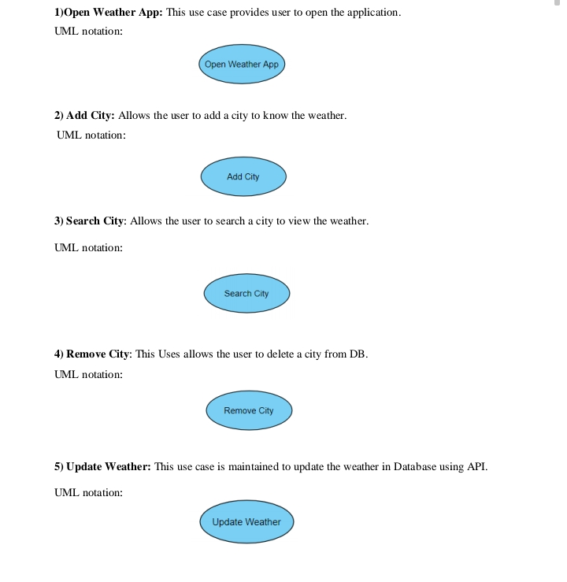

FOR ADD CITY: 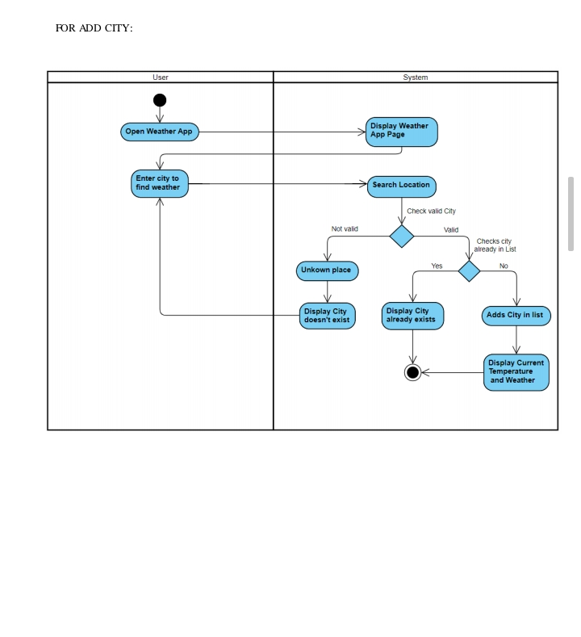

**CODE: FOR HTML**

**<!DOCTYPE html>**

**<html lang="en">**

**<head>**

**<meta charset="UTF-8">**

**<meta http-equiv="X-UA-Compatible" content="IE=edge">**

**<meta name="viewport" content="width=device-width, initial-scale=1.0">**

**<title>Weather App With JavaScript</title>**

**<link rel="stylesheet" href="chandu.css">**

**</head>**

**<body>**

**<div class="container">**

**<div class="header">**

**<div class="search-box">**

**<input type="text" placeholder="Enter your location" class="input-box">**

**<button class="fa-solid fa-magnifying-glass" id="searchBtn"></button>**

**</div>**

**</div>**

**</div>**

**<div class="weather-body">**

**<img src="cloud1.png" alt="Weather Image" class="weather-img">**

**<div class="weather-box">**

**<p class="temperature">0 <sup>°C</sup></p>**

**<p class="description">light rain</p>**

**</div>**

**<div class="weather-details">**

**<div class="humidity">**

**<i class="fa-sharp fa-solid fa-droplet"></i>**

**<div class="text">**

**<span id="humidity">45%</span>**

**<p>Humidity</p>**

**</div>**

**</div>**

**<div class="wind">**

**<i class="fa-solid fa-wind"></i>**

**<div class="text">**

**<span id="wind-speed">12Km/H</span>**

**<p>Wind Speed</p>**

**</div>**

**</div>**

**</div>**

**</div>**

**</div>**

**<script src="sruthi.js"></script>**

**<script src="https://kit.fontawesome.com/595a890311.js" crossorigin="anonymous"></script>**

**</body>**

**</html>**

**CODE FOR JAVA SCRIPT:**

**const inputBox = document.querySelector('.input-box');**

**const searchBtn = document.getElementById('searchBtn');**

**const weather_img = document.querySelector('.weather-img');**

**const temperature = document.querySelector('.temperature');**

**const description = document.querySelector('.description');**

**const humidity = document.getElementById('humidity');**

**const wind_speed = document.getElementById('wind-speed');**

**const location_not_found = document.querySelector('.location-not-found');**

**const weather_body = document.querySelector('.weather-body');**

**async function checkWeather(city){**

**const api_key ="5ecd03efa7a9d8c3baf3ce290f73d07d" ;**

**const url = `https://api.openweathermap.org/data/2.5/weather?q=${city}&appid=${api_key}`;**

**const weather_data = await fetch(`${url}`).then(response => response.json());**

**if(weather_data.cod === `4041`){**

**location_not_found.style.display = "flex";**

**weather_body.style.display = "none";**

**console.log("error");**

**return;**

**}**

**console.log("run");**

**location_not_found.style.display = "none";**

**weather_body.style.display = "flex";**

**temperature.innerHTML = `${Math.round(weather_data.main.temp - 273.15)}°C`;**

**description.innerHTML = `${weather_data.weather[0].description}`;**

**humidity.innerHTML = `${weather_data.main.humidity}%`;**

**wind_speed.innerHTML = `${weather_data.wind.speed}Km/H`;**

**switch(weather_data.weather[0].main){**

**case 'Clouds':**

**weather_img.src = "cloud1.png";**

**break;**

**case 'Clear':**

**weather_img.src = "clear1.png";**

**break;**

**case 'Rain':**

**weather_img.src = "rain1.png";**

**break;**

**case 'Mist':**

**weather_img.src = "mist1.png";**

**break;**

**case 'Snow':**

**weather_img.src ="snow2.jpg";**

**break;**

**}**

**console.log(weather_data);**

**}**

**searchBtn.addEventListener('click', ()=>{**

**checkWeather(inputBox.value);**

**});**

**CODE FOR CSS:**

**\*{**

**margin: 0;**

**padding: 0;**

**box-sizing: border-box;**

**border: none;**

**outline: none;**

**font-family: sans-serif;**

**}**

**body{**

**min-height: 100vh;**

**display: flex;**

**justify-content: center;**

**align-items: center;**

**background-color: #fbf2f9;**

**}**

**.container{**

**width: 400px;**

**height: min-content;**

**background-color: hwb(213 61% 7%);**

**border-radius: 12px;**

**padding: 28px;**

**}**

**.search-box{**

**width: 100%;**

**height: min-content;**

**display: flex;**

**justify-content: space-between;**

**align-items: center;**

**}**

**.search-box input{**

**width: 84%;**

**font-size: 20px;**

**text-transform: capitalize;**

**color: #000;**

**background-color: #e6f5fb;**

**padding: 12px 16px;**

**border-radius: 14px;**

**}**

**.search-box input::placeholder{**

**color: #000;**

**}**

**.search-box button{**

**width: 46px;**

**height: 46px;**

**background-color: hsl(196, 41%, 78%);**

**border-radius: 50%;**

**cursor: pointer;**

**font-size: 20px;**

**}**

**.search-box button:hover{**

**color: #fff;**

**background-color: #ababab;**

**}**

**.weather-body{**

**justify-content: center;**

**align-items: center;**

**flex-direction: column;**

**margin-block: 20px;**

**display:flex;**

**}**

**.weather-body img{**

**width: 60%;**

**}**

**.weather-box{**

**margin-block: 20px;**

**text-align: center;**

**}**

**.weather-box .temperature{**

**font-size: 40px;**

**font-weight: 800;**

**position: relative;**

**}**

**.weather-box .temperature sup{**

**font-size: 20px;**

**position: absolute;**

**font-weight: 600;**

**}**

**.weather-box .description{**

**font-size: 20px;**

**font-weight: 700;**

**text-transform: capitalize;**

**}**

**.weather-details{**

**width: 100%;**

**display: flex;**

**justify-content: space-between;**

**margin-top: 30px;**

**}**

**.humidity, .wind{**

**display: flex;**

**align-items: center;**

**}**

**.humidity{**

**margin-left: 20px;**

**}**

**.wind{**

**margin-right: 20px;**

**}**

**.weather-details i{**

**font-size: 36px;**

**}**

**.weather-details .text{**

**margin-left: 10px;**

**font-size: 16px;**

**}**

**.text span{**

**font-size: 20px;**

**font-weight: 700;**

**}**

**.location-not-found{**

**margin-top: 20px;**

**display: none;**

**align-items: center;**

**justify-content: center;**

**flex-direction: column;**

**}**

**.location-not-found h1{**

**font-size: 20px;**

**color: hsl(0, 88%, 75%);**

**margin-block-end: 15px;**

**}**

**.location-not-found img{**

**width: 80%;**

**}**

**RESULT**

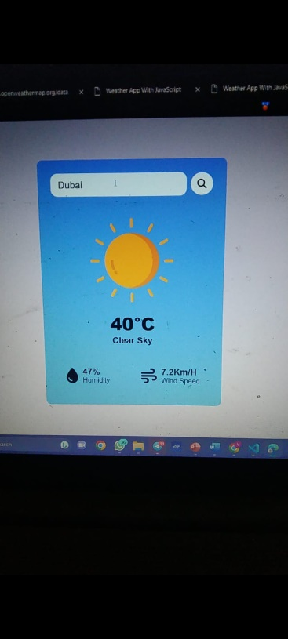 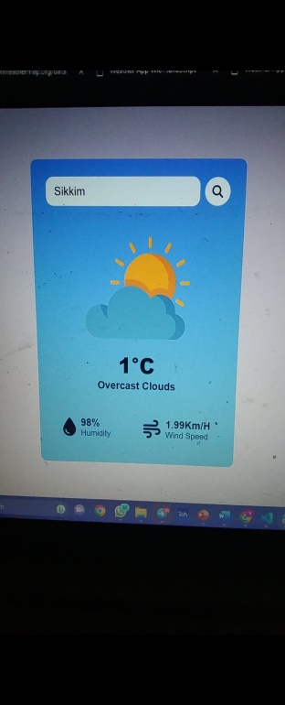

**ADVANTAGES**

Instant information availability. Improved Weather forecast. Easy Flow of Information. Widget Support

* Farmers can known when to plant or harvest their crops
* People cam choose where and when to take their holidays to take advantages of good weather
* Surfers known when large waves are expected
* Regions can be evacuated if hurricanes or floods are expected
* Aircraft and shipping rely heavily on accurate weather forecasting

**DIS-ADVANTAGES**

The weather changes very rapidly, and even the most reliable computer models are prone to error and inconsistencies. The apps do not take geography or microclimates into account and have problems forecasting for snow and thunderstorms.

Weather is extremely difficult to forecast correctly

* It is expensive to monitor-so many variables from so many sources
* The computers needed to perform the millions of calculations necessary are expensive
* The weather forecasters get blamed if the weather is different from the forecast.

**APPLICATIONS**

The importance of accurate weather forecasts cannot be over emphasized as the needs for them are always craved for in virtually every aspect of life. These forecasts can be applied in the following areas:

* Severe weather alerts and advisories

A major part of modern weather forecasting is the severe weather alerts and advisories, which the national weather services issue in the case that severe or hazardous weather is expected. This is done to protect life and property.

* Marine

Commercial and recreational use of waterways can be limited significantly by wind direction and speed, wave periodicity and heights, tides, and precipitation. These factors can each influence the safety of marine transit

* Agriculture

Farmers rely on weather forecasts to decide what work to do on any particular day. For example, drying hay is only feasible in dry weather. Prolonged periods of dryness can ruin cotton, wheat, and corn crops.

* Air Traffic

Because the aviation industry is especially sensitive to the weather, accurate weather forecasting is essential considering the fact that a greater number of plane crashes recorded the world over have weather related causes.

**CONCLUSION**

From this we can conclude that a weather application can be of great help to users, especially with the increasing use of smartphones and the convenience they provide. Weather applications can be developed for various platforms, but due to the large user base of Android, developing an Android weather app would allow for access to a larger customer base. Android apps are also comparatively cheaper and more accessible, making it easier for users to have access to the app. The weather application will provide users with real-time weather information, forecasts, and other weather-related data, which can help them make better decisions about their day-to-day activities. Additionally, the weather app can provide users with statistical information and trends, which can help them monitor weather patterns over time and make data-driven decisions. Overall, a weather application can be a useful tool for users to stay informed about weather conditions and make better decisions based on that information.

**FUTURE SCOPE**

The future of weather applications is promising, with the increasing demand for real-time and accurate weather information. One potential development is the improvement in accuracy through the use of advanced data collection and analysis techniques, as well as sophisticated algorithms. This will lead to more reliable weather forecasts, helping individuals and organizations make informed decisions. Personalization is another area where weather applications are likely to evolve. These apps will offer customized forecasts and alerts based on a user's location, preferences, and behavior. This personalization will make weather information more relevant and useful for the user. Finally, weather applications will become more intuitive and user-friendly, using visualizations and other tools to help users understand complex weather data more easily.

**\*\*\***